**For Add on card scenario -**

1.2nd verbiage in the blue box to be removed in case of add-on card in both desktop and mobile view.

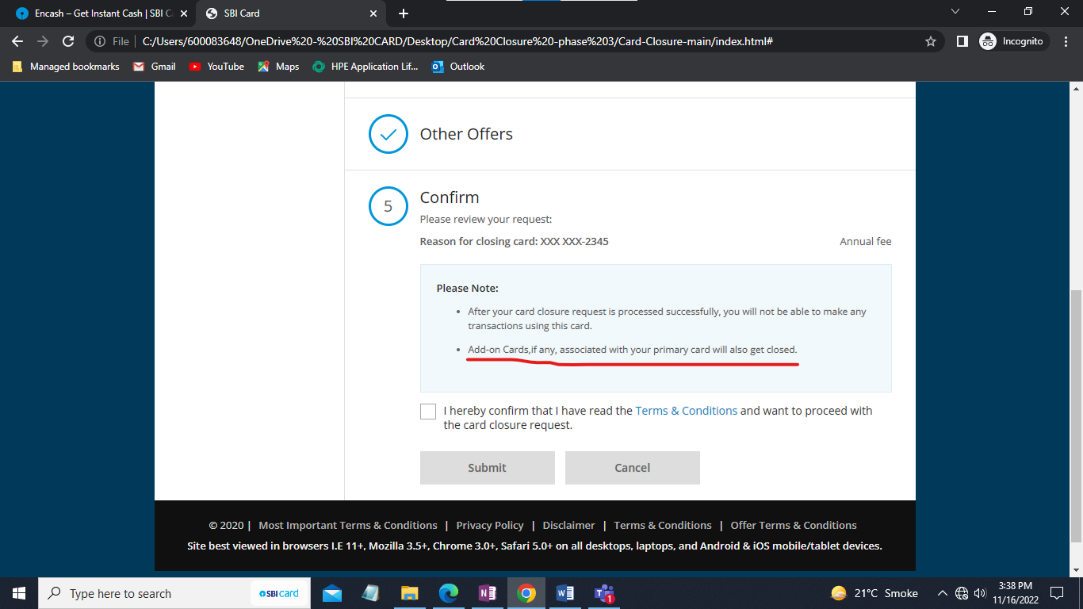

2.TnC check box is not clickable in mobile view in all devices.

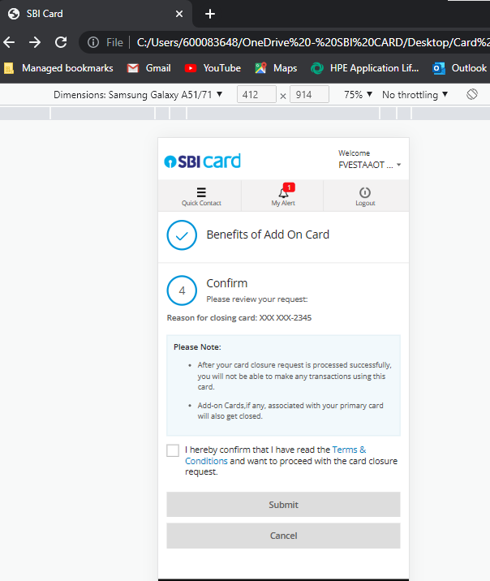

**For both Primary and Add-on card scenario –**

1.Line coming below Submit, Cancel and resend OTP CTA in both desktop and mobile view.

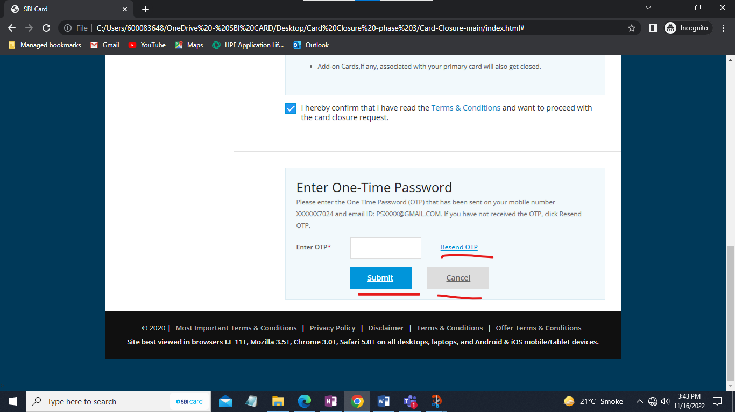

2.OTP field taking more than 6 digits and e alphabet in both desktop and mobile view.

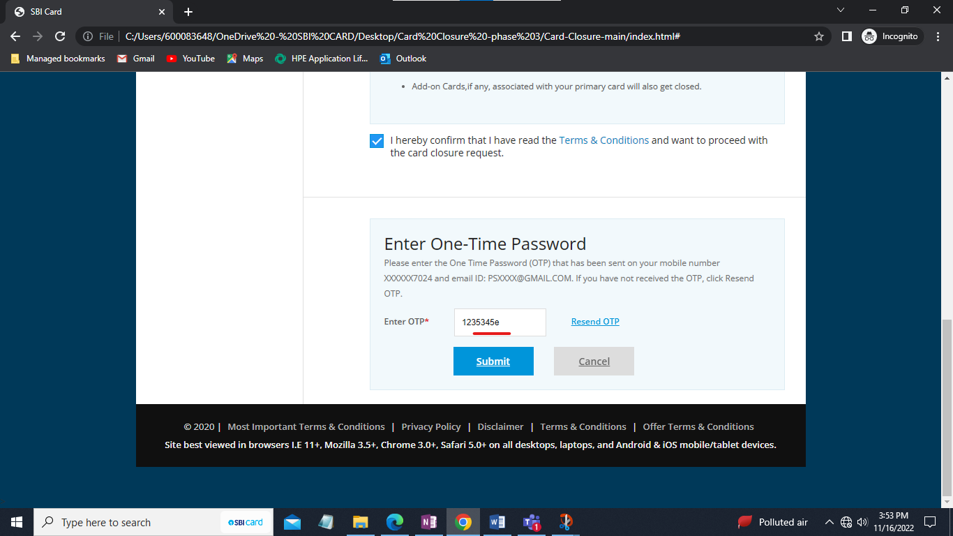

3.Time and date dropdown should come.

4.Cross present in the right side of pop-up is not working in both desktop and mobile view.

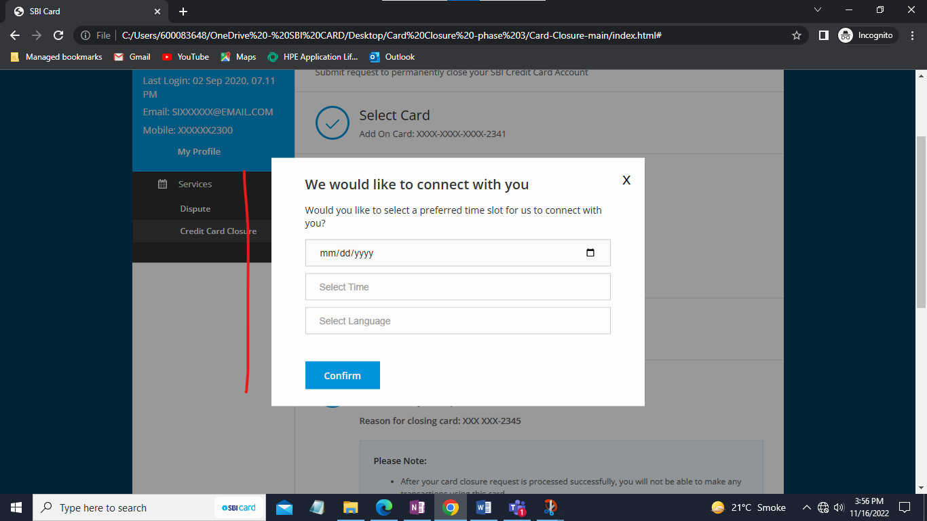

5.Request received successfully Heading font size to decrease – Please make it 18PX.

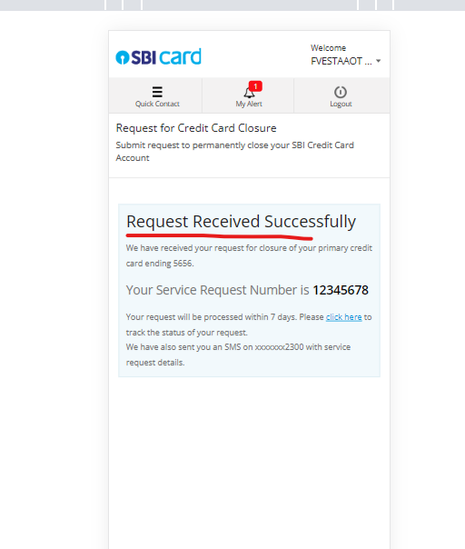

**Primary card scenario –**

**Annual fee scenario -**

1. Flow is not correct - After clicking on avail offer CTA (Step 3), more offers tab is opening (Step 4), Ideally Success SR page should come.
2. In 4th step while clicking on avail offer CTA, confirm page is opening (Step 5), ideally Success SR page should come.
3. Skip CTA is not working correctly in 3rd and 4th step, if we are clicking on skip CTA in 3rd step (Personalized offers) it should take us to 4th step (Other offers), similarly if we are clicking on skip CTA in 4th step it should take us to 5th step (Confirm page).
4. Card closure SR getting created verbiage is coming even after we have selected offers and haven’t raised the card closure request.

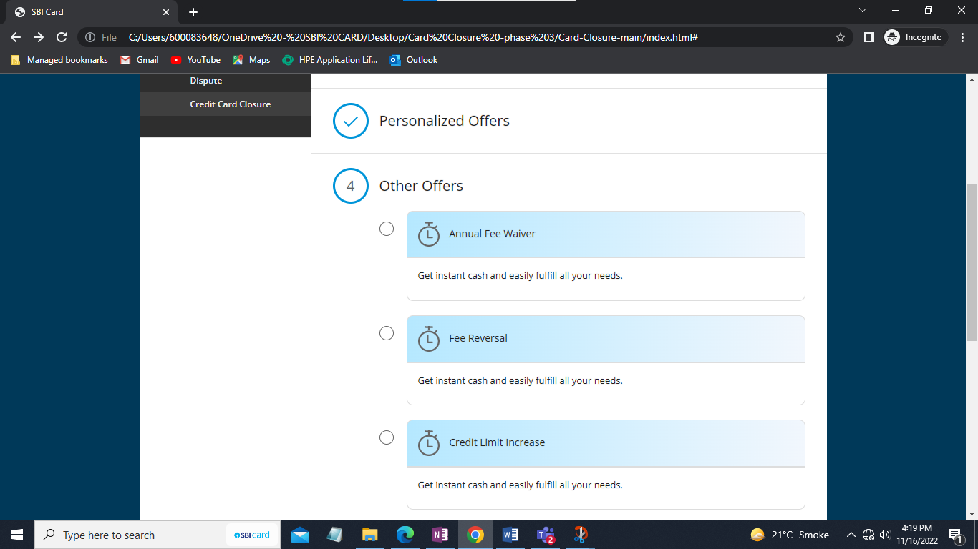

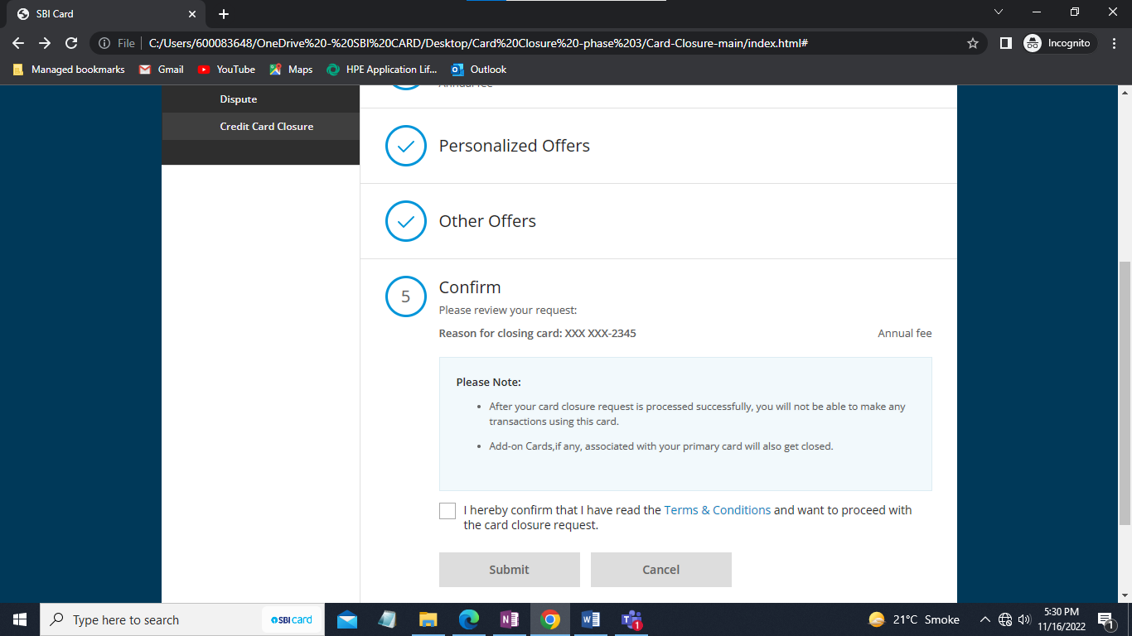

5.Banner getting truncated from right side in mobile view in all devices for all primary card scenario.

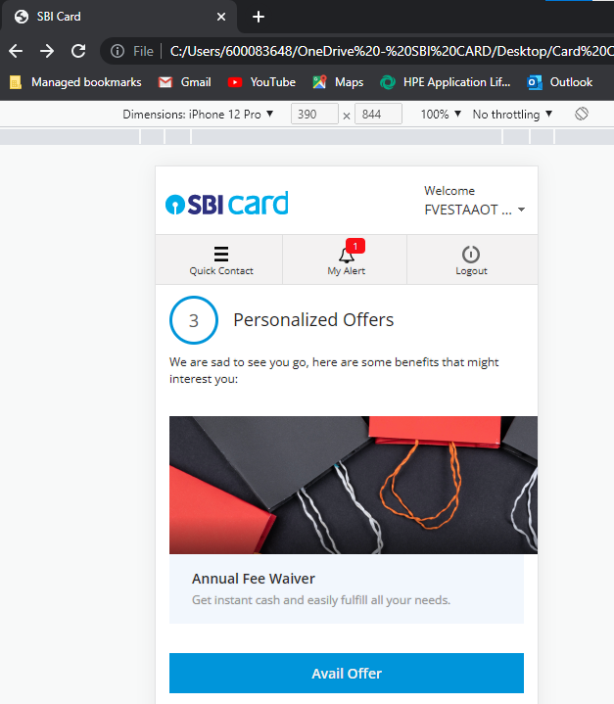

**Low Credit Limit –**

1. Incorrect successful screen verbiage is coming, showing card closure request received even after selecting the Okay CTA.

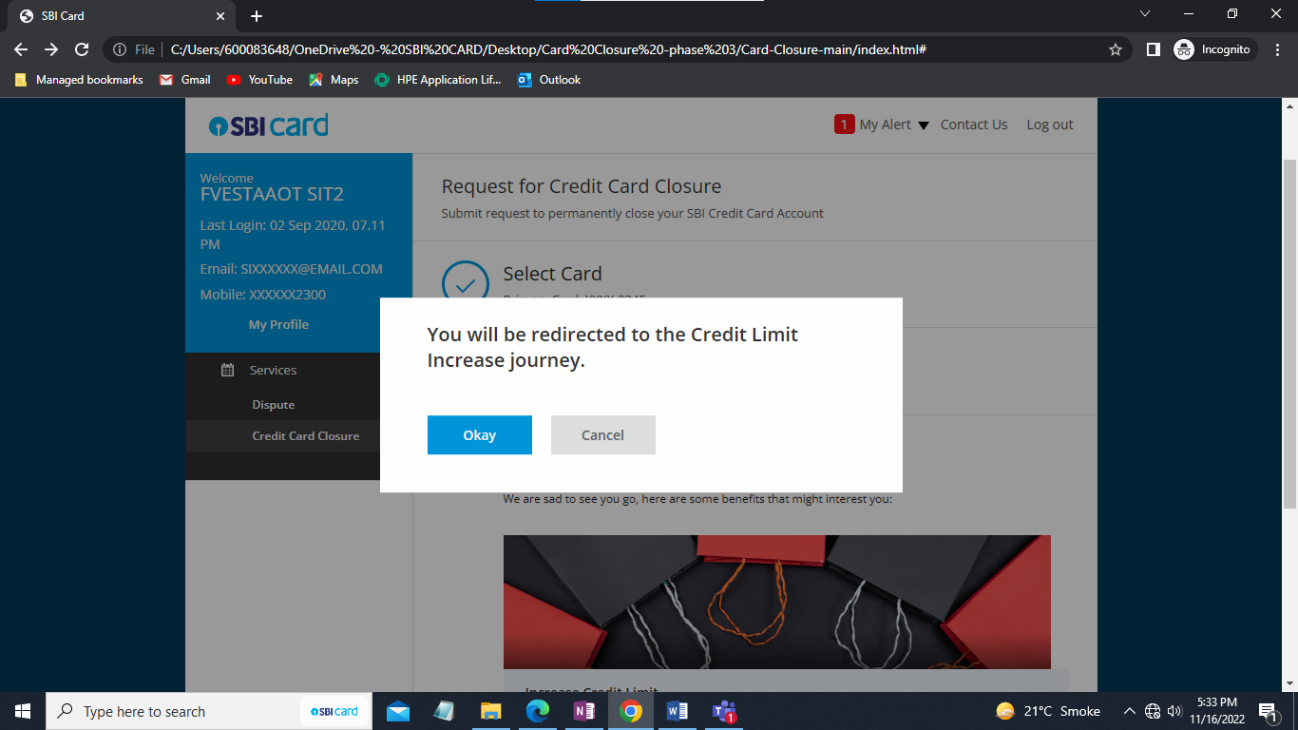

**Billing cycle scenario –**

1. Current and new billing cycle Box and dropdown getting truncated from right side in mobile view.
2. Also, Incorrect successful screen verbiage is coming, showing card closure request received even after selecting the Avail offer CTA.

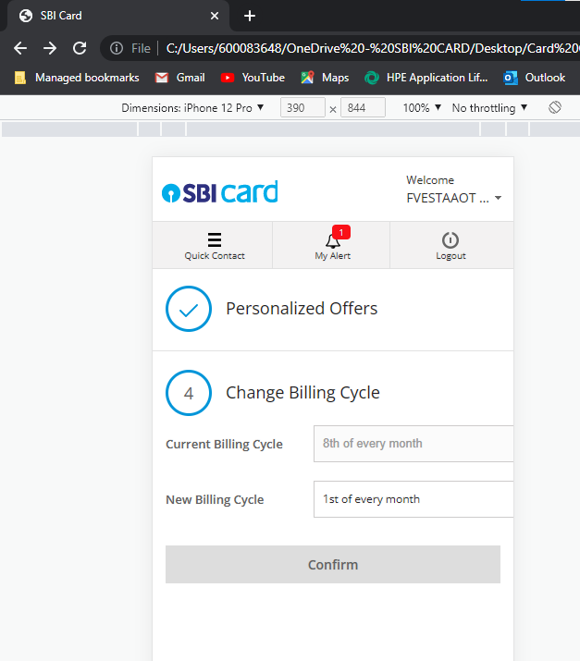

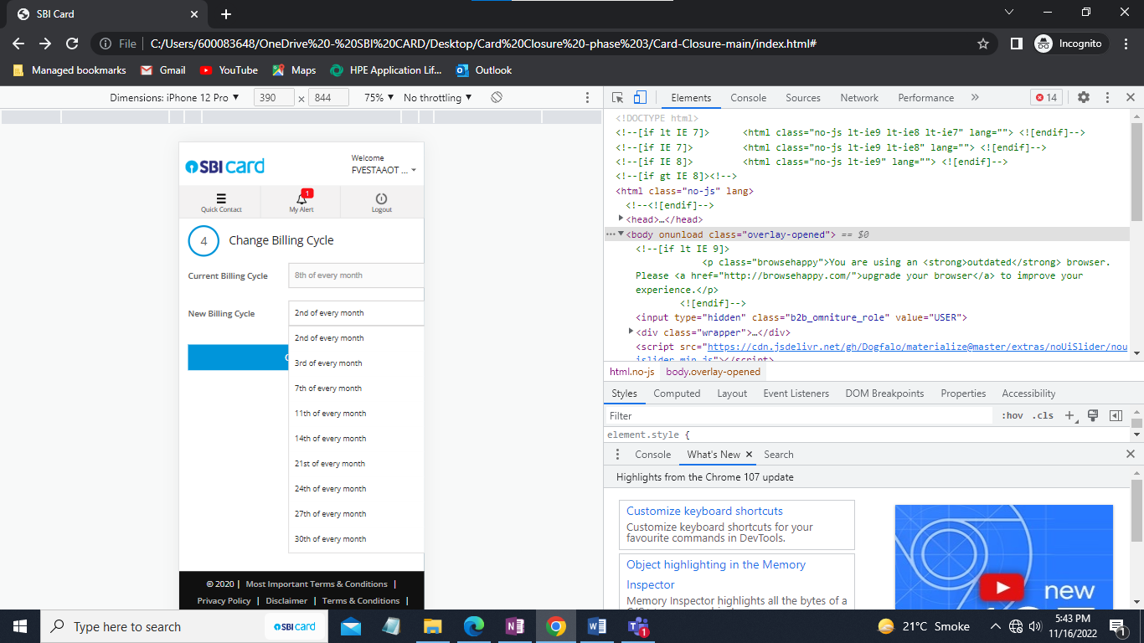

**More offer scenario –**

Step 3 – Personalized offers don’t come in case of more offer, Please remove -

1. In More offers step while clicking on avail offer CTA, Confirm page is opening, ideally Success SR page should come. Please check.
2. Skip CTA is not working correctly in More offers step, if we are clicking on skip CTA in More offers step it should take us to Confirm page.
3. Card closure SR getting created verbiage is coming even after we have selected offers and haven’t raised the card closure request.

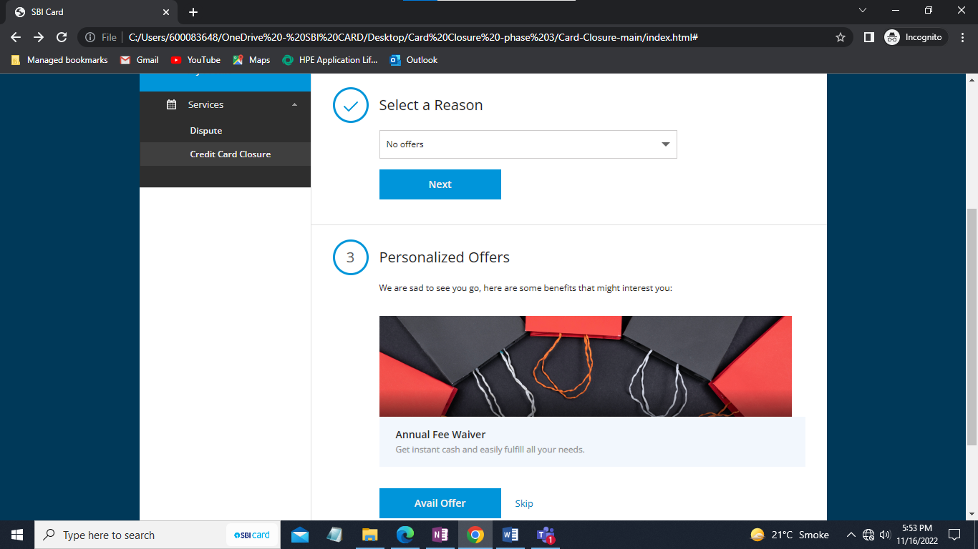

**Other Fees and Charges scenario –**

1. Incorrect successful screen verbiage is coming, showing card closure request received even after selecting the Avail offer CTA.

**Other scenario –**

1. Please elaborate’ box getting truncated from right side in mobile view in all devices.

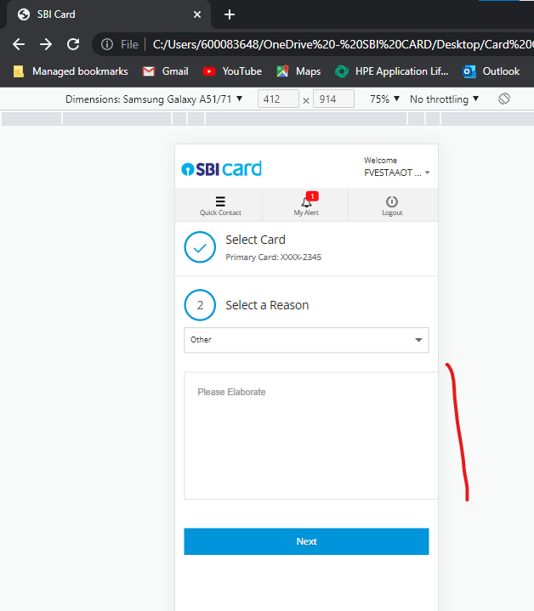

1. Next CTA to remain disabled until anything is being filled in the ‘Please elaborate’ box.

